 | Monday | Tuesday | Wednesday | Thursday
1st– 4th | Water and Bubbles | Sports Day | Art Attack | Mad Hatters Tea Part y
15th –  18th | Woodland Walks | Tasty Treat Boxes | Ninja Spies | 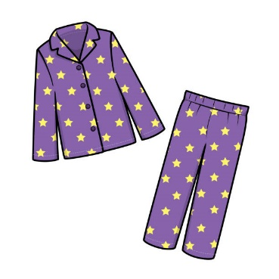  Jimmy Jam Jamboree
22nd – 25th | Wildlife Detectives | XP Kids Olympics | Science Extravaganza | Team Games
29th– 1st | Bank Holiday | Fun in the Sun | 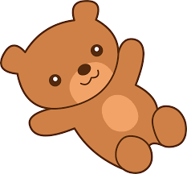  Teddy Bears Picnic | End of Summer Party
Water and Bubbles : Bring your swimmers and a towel
Sports Day : Bring your trainers
Art Attack : Bring your apron
Mad Hatters Tea Party : Dress up in your favourite costume
Woodland Walks : Bring your trainers
Tasty Treat Boxes : Bring your apron
Ninja Spies: Wear your best disguise
Jimmy Jam Jamboree : Wear your PJs, bring a duvet/blanket and something to cuddle
Wildlife Detectives : Bring your trainers
XP Kids Olympics : Bring your trainers
Science Extravaganza : Bring your apron
Team Games : Bring your trainers
Fun in the Sun : Bring your swimmers and a towel
Teddy Bears Picnic : Bring your favourite teddy and a book to read
End of Summer Party : Only bring a pack lunch if you’re here till 5:30

